SOFTWARE TESTING – TUTORIAL 5

Module Name: Defect Identification and Bug Reports – SauceDemo

Webpage URL:tps://www.saucedemo.com/ht

TC01 – Verify Invalid Login Handling

Test Case: Verify invalid login credentials are handled correctly.

Steps:

Open SauceDemo website.

Enter an invalid username.

Enter an invalid password.

Click Login.

Observe the error message.
Screenshot: 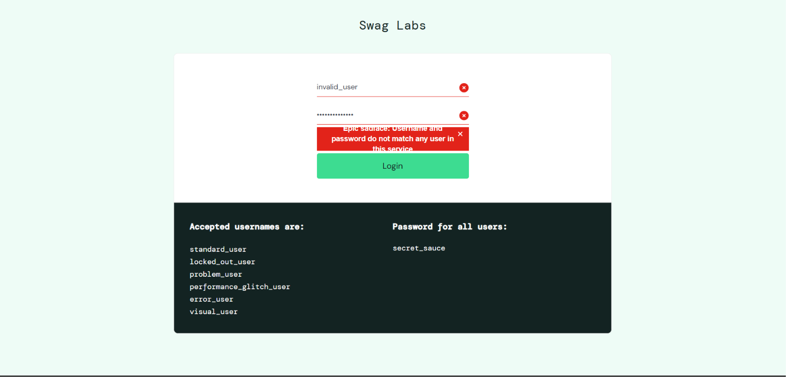

TC02 – Verify Required Checkout Field Validation
Test Case: Verify required checkout field validation.
Steps:
- Open SauceDemo website.
- Login with valid credentials.
- Add any product to the cart.
- Open the cart and click Checkout.
- Leave the First Name field blank.
- Enter Last Name and ZIP/Postal Code.
- Click Continue.
Screenshot: 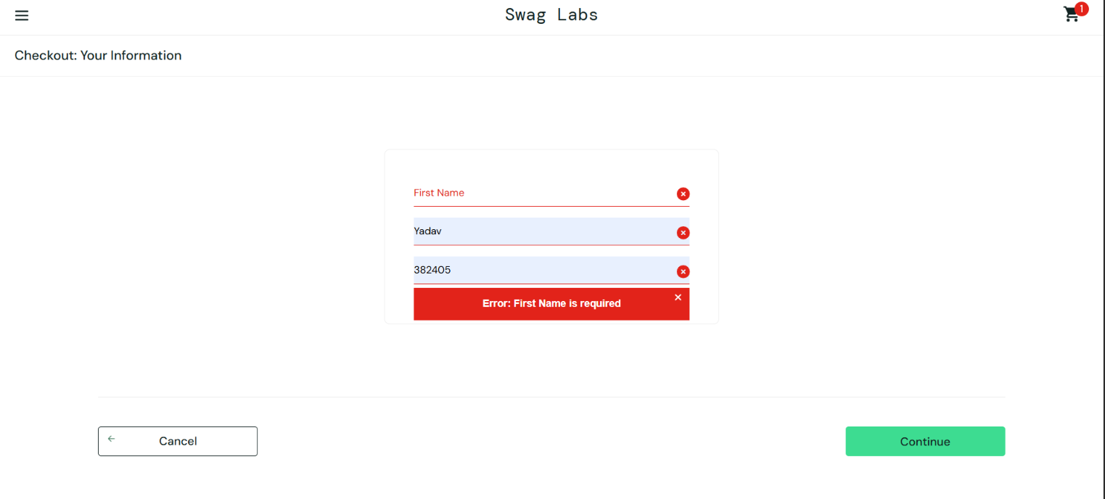

TC03 – Verify Cart Total After Adding Product
Test Case: Verify that the cart displays the correct product price and total amount.
Steps:
- Open SauceDemo website.
- Login with valid credentials.
- Add Sauce Labs Backpack to the cart.
- Open the cart.
- Check the product price and total.
Screenshot:
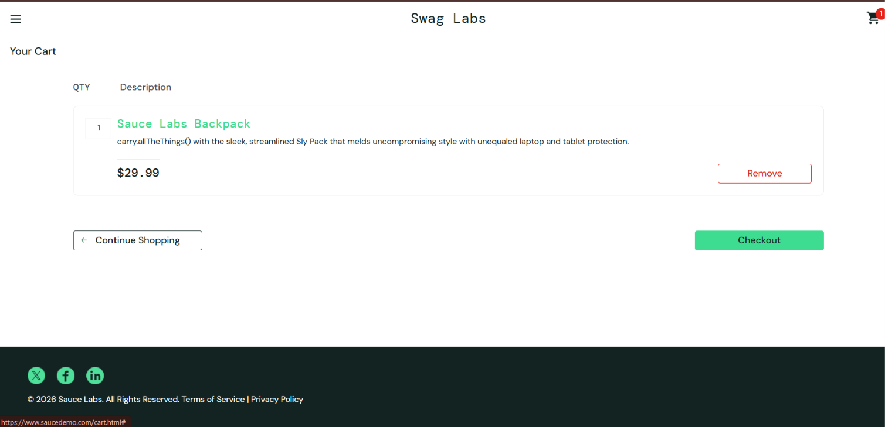

TC04 – Verify Checkout Layout on Smaller Screen
Test Case: Verify checkout page layout on a smaller screen.
Steps:
- Open SauceDemo website.
- Login with valid credentials.
- Add Sauce Labs Backpack to the cart.
- Open the cart and click Checkout.
- Resize the browser window to a smaller size.
- Observe the checkout fields and buttons.
Screenshot: 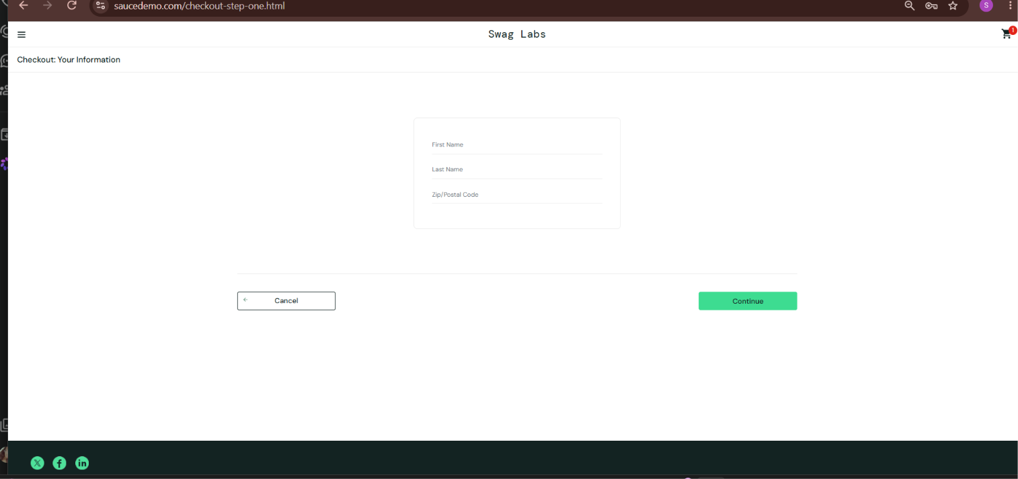

TC05 – Verify Payment Information Handling
Test Case: Verify payment information is displayed correctly during checkout.
Steps:
- Open SauceDemo website.
- Login with valid credentials.
- Add a product to the cart.
- Open the Cart and proceed to checkout.
- Enter the required checkout details.
- Click Continue.
- Observe the Payment Information section.
Screenshot: 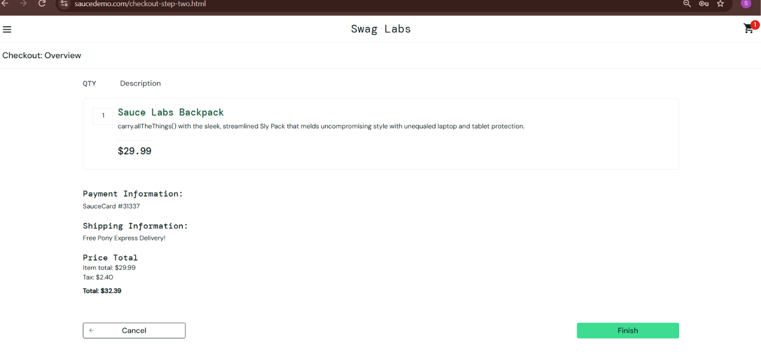

Bug Report – BUG-001
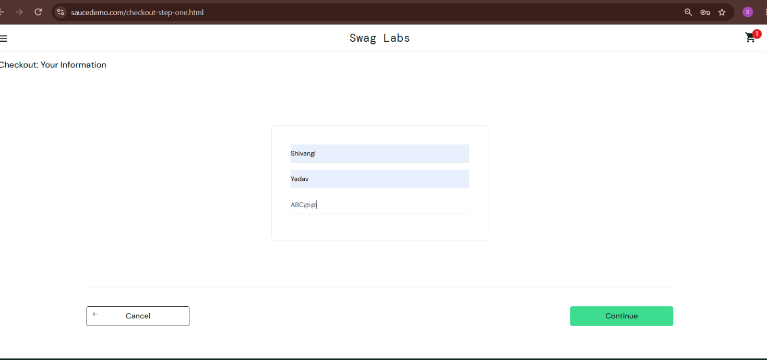
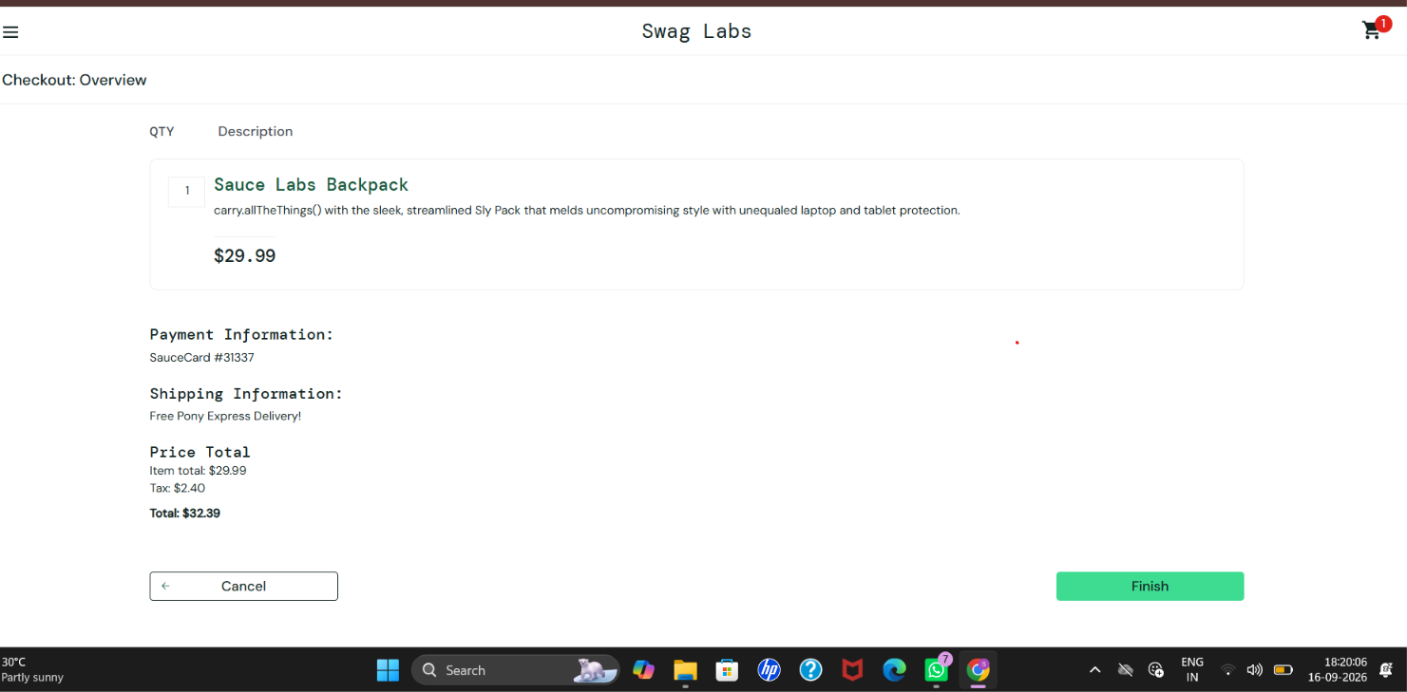

Conclusion
The SauceDemo application was tested using five test cases. All five test cases were executed successfully with a 100% pass rate. During testing, one issue was identified in the ZIP/Postal Code field, where invalid characters were accepted. The issue was documented as BUG-001.

